

**e-Yantra Robotics Competition - 2015**

**Implementation Analysis – Hazardous Waste Disposal**

**<Team ID>**

|  |  |
| --- | --- |
| **Team leader name** | **Abhishek Acharya** |
| **College** | **National Institute of Technology, Meghalaya** |
| **Email** | **abhi11796acharya@gmail.com** |
| **Date** | **16-01-2016** |

<This report contains three sections:

1. Preparing the Arena

2. Design Analysis

3. Algorithm Analysis

Teams have to answer question/s from these sections according to their understanding of the theme and the given Firebird V robot. >

**Preparing the Arena (5)**

<

Prepare the arena according to the steps given in Section 3: Arena, of the rulebook. Take a photo of the completed arena such that the entire arena is clearly visible in the photo. Insert the image here

>

**Design Analysis**

**Q-1. How will you detect the Low CCL and High CCL Hazardous Wastes? (10)**

Sensors which would be used for detecting hazardous wastes are:-

1. Sharp IR range Sensors
2. Color Sensors

Sharp IR range sensor would detect presence of hazardous waste and the color sensors would detect whether the waste is Low CCL or High CCL.

Working of Sharp IR range Sensors

The Sharp IR Range Sensors use triangulation and a small linear CCD array to compute the distance or the presence of objects in the field of view. A pulse of light is emitted by the emitter and then reflected back if there is any object or not reflected at all if there is no object. If the light reflects off an object, it returns to the detector and creates a triangle between the point of reflection, emitter and the detector. The angle is measured using the CCD array to estimate distance from the obstacle and this angle derives the distance to the object.

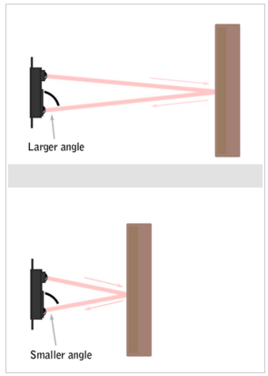

Working of Color Sensors

The color sensor TCS3200 works on the principle of current to frequency convertor. Basically TCS3200 senses the color light and converts it into frequency using the combine configurable silicon photodiodes and a current-to frequency converter on a single monolithic CMOS integrated circuit. The output of the color sensor is a square wave which is counted using counter/timer programming in the microcontroller.

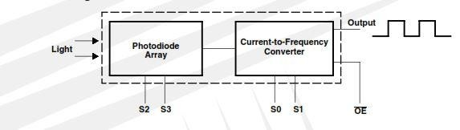

Whenever anyone RGB color is hindered in front of the sensor, it generates the corresponding frequency. The frequency depends on the intensity of reflection by the hindrance. The reflecting frequency for same color of obstruction and photodiode will be much higher. Since black color absorbs all the spectrum of light so the frequency obtained is below threshold value.

**Q-2. Draw a labeled diagram to explain how you have planned to place the sensors on/around the robot? (10)**

<

Draw a neat diagram to show the positions of sensors on and around the robot. Show all the sensors you are using in designing the theme. Justify placement of the sensors shown in your diagram

>

**Q-3. Teams have to make the robotic arm for picking up/placing the Hazardous Wastes in the arena.**

1. **Choose an option you would like to use to position the robotic arm on the robot and why? (5)**

1. **Front 2. Back 3. Right/Left 4. On both sides**

**Answer: ____________________**

<

Justify your choice for placement of the robotic arm.

Word-limit: 300 words

>

1. **Draw a diagram to show the robotic arm and how it is mounted on the robot. Also show the mounting of the color sensor. (10)**

<

Draw figure(s) to show how you are planning to mount the robotic arm and the color sensor on the robot.

>

**Q-4. Choose the actuator you will use to design the robotic arm. (5)**

1. **DC-Motor 2. Servo Motor 3. Stepper Motor 4. Others**

**Answer: ___Servo motor______________**

**Justify your answer by stating the advantage of the chosen actuator over others. Also give reasons for not using other actuators.**

**Q-5. How will you identify Red, Blue and Green colors from the values you get from the color sensor? Explain your algorithm to identify the three colors (Red, Blue and Green). (10)**

Identification of Red, Blue and Green colors

* Photodiodes can be selected using the S2 and S3 pins

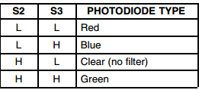

* RED, GREEN, BLUE photodiode are selected and number of pulses received for each of the photodiode are stored.
* Then these pulses are compared.
* The highest number of pulses indicates the color which is being identified.
* For example: GREEN color is to be identified. Then values for corresponding photodiode will around  
   a. RED -around 4000

b. BLUE – around 3800

c. GREEN – around 10000

So it will be clear from the observation that the color would be GREEN.

* Similarly RED and BLUE can be identified.

Algorithm for identification of three colors

* Different variables are declared and initialized to store the pulse count when different color function is called
* Interrupt 0 is enabled for the color sensor.
* Port for LCD and Color sensor is defined.
* Different color functions are made: -  
   a. For detecting RED color, S2 and S3 are set to low.  
   b. For detecting GREEN color, S2 and S3 are set to high.  
   c. For detecting BLUE color, S2 is set to low and S3 is set to high.
* Then different functions are made to select above function and display the number of pulses of different color.
* In the main function, above mentioned function is continuously run in order to get the pulses for a particular color.
* The highest number of pulses indicates the color which being detected.
* Suppose if the RED is to be identified, then the number of pulses for RED will be very high as compared to GREEN or BLUE and hence it will clear that the color is RED.
* Similarly GREEN and BLUE would be identified.

**Q-6. (15)**

**a. How will you determine the Orientation of the Bridge?**

<

List the sensors and explain the mechanism used to determine the orientation of the Bridge. Write the answer in your own words

>

**b. How many times will the orientation of the Bridge change to complete the entire task, as per your solution? Explain in steps, how many Weight Blocks are added to Containers at DZ1 and DZ2 each time the robot changes the Orientation of the Bridge, considering the following cases:**

**Case 1. If the bridge is initially “tilted toward CA”**

**Case 2. If the bridge is initially “tilted toward IA”**

<

Case 1: If the bridge is initially “tilted toward CA”

The number of times the orientation of the Bridge needs to be changed is 4.

Step 1: At DZ1 – number of Weight Block added is 1

Step 2: At DZ2 – number of Weight Block added is 1

Step 3: At DZ1 – number of Weight Block added is 1

Step 4: At DZ2 – number of Weight Block added is 1

Case 2: If the bridge is initially “tilted toward IA”

The number of times the orientation of the Bridge needs to be changed is 5.

Step 1: At DZ2 –number of Weight Block added is 1

Step 2: At DZ1 –number of Weight Block added is 1

Step 3: At DZ2–number of Weight Block added is 1

Step 4: At DZ1 –number of Weight Block added is 1

Step 5: At DZ2–number of Weight Block added is 1

>

**c. The maximum number of Weight Blocks required if the bridge is initially:**

**1. “tilted toward CA”= _____________**

**2. “tilted toward IA”=**  _____________

Based on the logic, maximum number of Weight Blocks required completing the entire task are:-

1. “Tilted towards CA” = 5
2. “Tilted towards IA” = 4

**Algorithm Analysis**

**Q-1 Draw a flowchart illustrating the major that are used. (10)**

<

The flowchart should elaborate on every possible function that you will be using for completing the assigned theme. Example: lineFollowing(), colorDetection() etc.

Follow the standard pictorial representation used to draw the flowchart.

>

Q-2 Draw a flowchart illustrating main function of your code. (20)

<

The flowchart should explain how you will be using the functions defined in the main program for completing the theme assigned to you.

Follow the standard pictorial representation used to draw the flowchart.

>